Happy Nursery Days’ / Ekaya Housing Association Limited
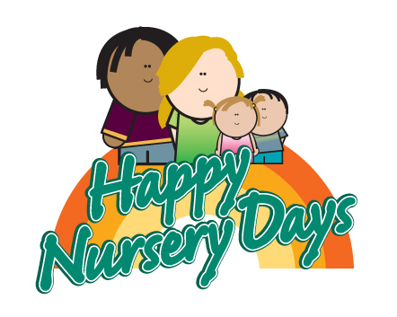

Early Years Practitioner

Reports To: Nursery Manager

Hours: 40 hours per week

JOB DESCRIPTION

OBJECTIVES OF POST

- To provide a high standard of the Revised EYFS statutory framework.
- To offer support and supervise other staff in the Nursery.
- To be a creative and reflective leader, able to implement new ideas and use a range of strategies to continually improve practice and support the management team.

KEY AREAS

- Work with Children
- Team Work
- Liaise with and support parents/ carers and their family members

MAIN DUTIES AND RESPONSIBILITIES

Nursery Nurses teach all areas of foundation stage, which is focused on helping the children to achieve learning goals. Activities include

- To understand and work to happy Nursery days policies and procedures ,including how to safeguard children and how to respond to incidents, accidents , complaints and emergencies at all times
- To effectively deliver the EYFS ensuring that the individual needs and interests of children in the setting are meet (in conjunction with other team members)
- To keep records of your key children development and learning journeys and share with parents, carers and other key adults in the child’s life
- Support all staff and engage in good staff team
- To develop and maintain strong partnerships and communication with parents/carers to facilitate day to day caring and early learning needs.

- Provide professional and relevant feedback to parents/carers about their child.
- To ensure the provision of a high quality environment to meet the needs of individual children having an awareness of any disabilities, family cultures and medical histories.
- To advise manager/deputy of any concerns, e.g. Over children, parents, the safety of the environment, preserving confidentiality as necessary.

- To be flexible within working hours, e.g. training, monthly staff meeting, summer fair etc.
- To be flexible within working practice of the setting, undertaking other responsible duties where needed, such as domestic tasks, preparation of snack meals, cleaning of equipment, etc.
- To work alongside the manager and staff team to ensure that the settings philosophy is full field
- To read and understand and adhere to all policies and procedures relevant to your role and the safe running of the setting
- To develop your role within the team especially with regards to being a key person. needs and inclusion.
- To keep completely confidential any information regarding the children ,their families or other staff that is acquired as part of the job
- To be aware of the high profile of the setting and to uphold its standards at all times, both in work hours and outside other agencies.
- To support nursery assistant ,students and volunteers
- To ensure good standards of safety, hygiene and cleanliness are maintained at all times.
- To undertake and lead an additional responsibilities such as SENCO,TRAINING CORIDANTION,SAFEGUARDING OFFICER

EQUAL OPPORTUNITIES

- To undertake any other duties commensurate with the post as agreed with the Chief Executive.

- In the undertaking of all duties to adhere and demonstrate commitment to Ekaya’s Equal Opportunities Policy.

This job description should be operated with reference to all of the Association’s agreed policies and procedures including Equal Opportunities, Health & Safety and the Staff Code of Conduct, however, as the post evolves, gradual changes to the duties may occur. Where substantial changes occur either which affect other post-holders or the level of responsibility of the post consultation will take place with the staff affected as appropriate.

Signed: _____________________________ Date: ___________________
(Post-holder)

Signed: _______________________ Date: ___________________
(Nursery Manager)
Happy Nursery Days’ / Ekaya Housing Association Limited

EARLY YEARS PRACTITIONER –

PERSON SPECIFICATION

Attributes | Criteria No. | Criteria
Relevant Experience | 1.  2.  3. | Experience in a day-care setting  Experience working with young children
Education and Training | 4.  5.  6.  7. | NVQ Level 3 in Early Years Care and Education  Diploma in Childcare Education  BTEC National Diploma in Early Years or equivalent
General and Special Knowledge | 8.  9.  10.  11.  12.  13.  14.  15. | Knowledge of Early Years Foundation Stage  Knowledge of Safeguarding Children, child protection issues and confidentiality  Knowledge of children’s learning and development  Knowledge of Special Educational needs and/or disability and Behaviour Management Understanding of Equal Opportunities  Knowledge of key-worker systems and record keeping  Awareness of Health and Safety and practical hygiene issues
Skills and Abilities | 16.  17.  18.  19.  20. | Ability to communicate well with adults and children  To be able to demonstrate the ability to work as part of a team  Ability to plan activity programme to stimulate learning and development, based on children’s individual needs  Ability to write clear observational assessments and evaluate children’s achievements Good report writing skills  Computer literate
Additional Factors | 21.  22.  23. | Good time management  Demonstrate creative ability  Good organisational skills

